First Grade News

Snapshot of the week:

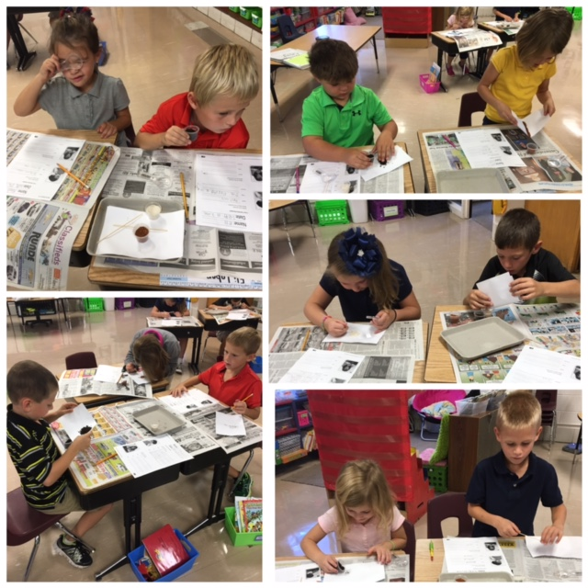

September 16, 2016

I hope your first grader was able to share with you the meaning of the word adjust. Look for our new word next Wednesday ☺

Katie Kieffer [katiekieffer@marquettecatholic.com](mailto:katiekieffer@marquettecatholic.com) 563-872-3284

Baby Bottles

We are collecting dollars and coins for the parish donation to the Clarity Clinic in Dubuque. If your first grader would like to help, have them bring in their coins/dollars by next Friday, the 23rd.

What we learned this week:

**Reading Groups:** We had a week full of uninterrupted reading group time and it was amazing! We focused on words with short i and I also started to teach the different rhymes and songs that I use to help students decode a word. For example, “The bossy e jumps over and tells the vowel to say its name like the word rake.”

**Math:** We are working diligently on our addition unit. This week we worked on making sums of 10 and started discussing some strategies like counting on, finding a double, and finding a sum of 10. We will continue with this next week.

**Science:** We started our Soils unit this week. The first graders did their first observation of clay, humus, and sand. This week they observed dry samples. Next week they will be observing wet samples.

Upcoming Events:

* Sept. 23rd – Spelling Test, Library Day, Have money in for Baby Bottle
* Sept. 27th – First Grade Mass
* Sept. 28th – Early Dismissal – 12:10